Freezing Panes on an Calc Worksheet

When creating a spreadsheet your columns or rows may move beyond the current view so that you will have to scroll across the table or down the table to insert new information. When you do this you will lose the headings that you have on the table. To get around this you can Freeze the Rows or Columns of your spreadsheet so that when you do scroll across the screen your headings are always in view.

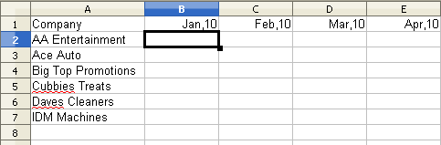

Move your cursor to the other side of the spreadsheet to above the Vertical Scroll bar. The cursor will change into a double jointed arrow.

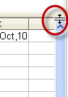

Click and hold the mouse button down (left unless you have changed the mouse configuration to right) and drag it down, you will see a black line appear on your spreadsheet.

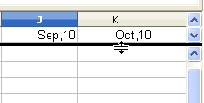

Release the mouse button just below the headings row. You have now frozen the headings into place.
You can also do this to columns as well. Move the cursor down to the right of the right facing Scroll button as shown below. Click and drag this between the 1st and 2nd column and release.

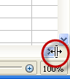

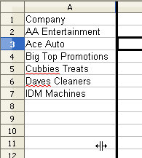

Your spreadsheet will now have two frozen panes so that when you scroll your headings will always be in view.



